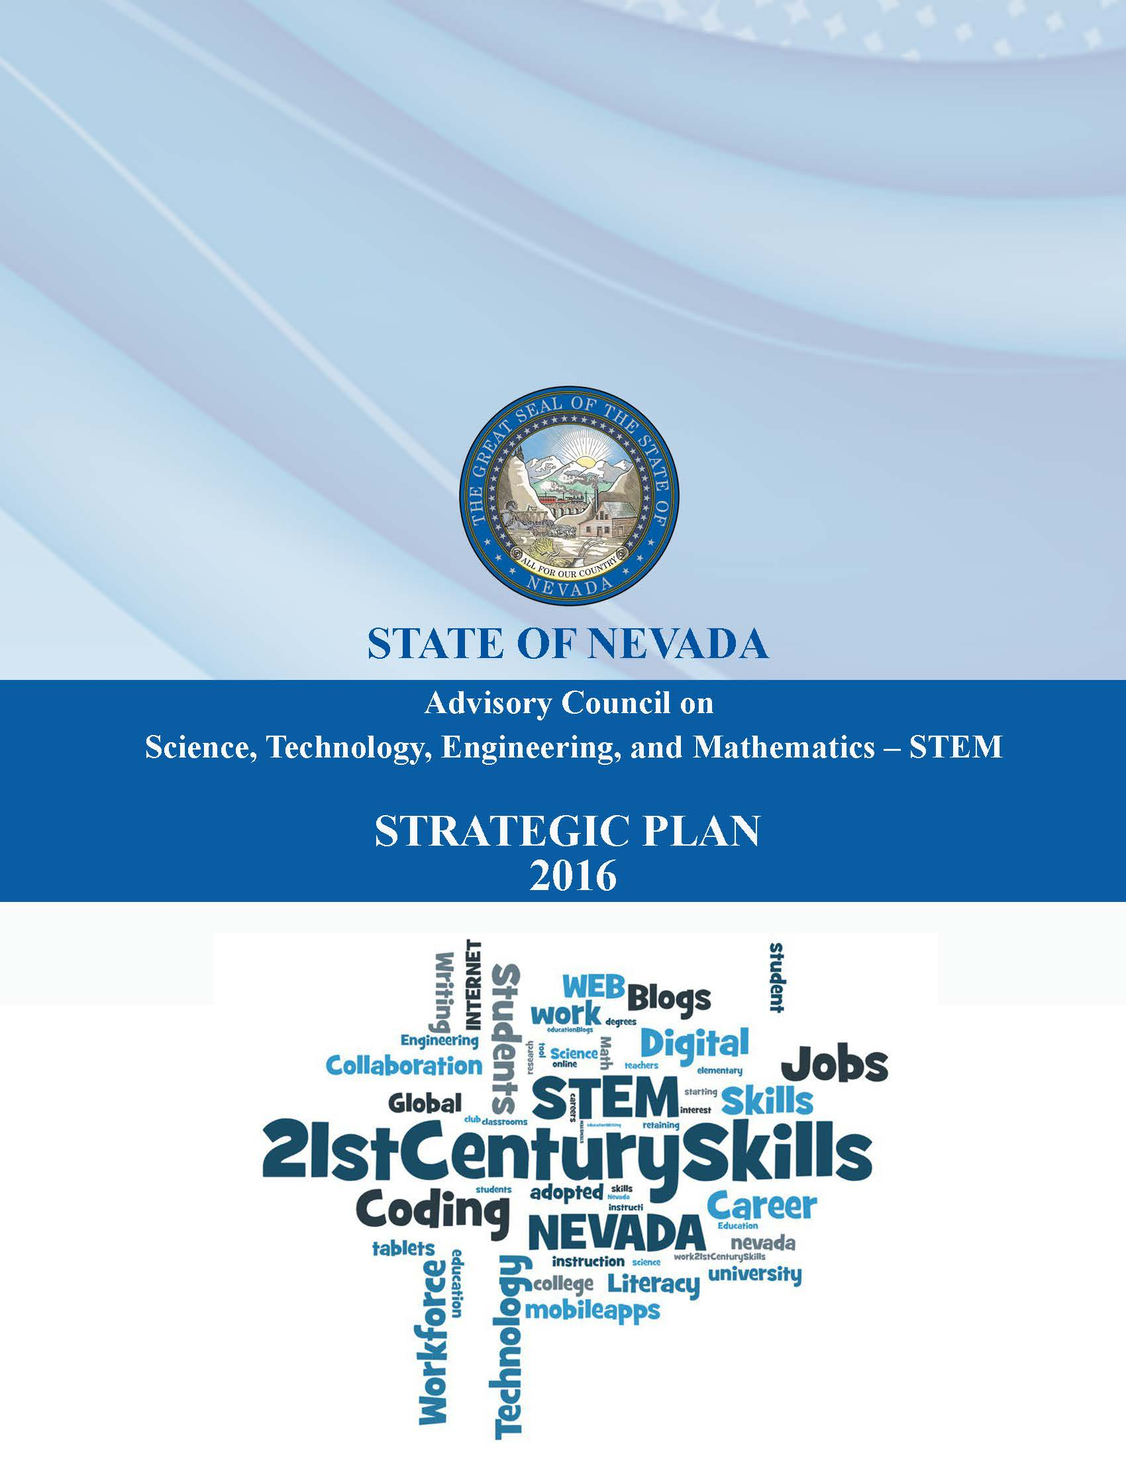
A STEM Strategic Plan for Nevada

Executive Summary
Nevada is changing. Where once as a state we were known mainly for our gaming, tourism, and hospitality industries, we have now added to our portfolio many new and exciting industries such as clean energy, robotics, battery manufacturing, drones, and autonomous vehicles. Nevada’s established industries are also changing as technology and entertainment collide. Together, these industries old and new are building the “New Nevada.” The common element in the industries of the New Nevada is the requirement for specialized knowledge and skillsets in Science, Technology, Engineering, and Mathematics (STEM).
As Nevada changes, so too does the world around it. Technology affects all aspects of life and we are connected instantaneously to events around the world. As the world grows more interconnected, its challenges grow in complexity. Change brings opportunities to solve new challenges. Nevada’s future depends on its students being prepared to meet a wide variety of challenges both at work and outside of it. Those who have a solid foundation in real-world problem solving and experimentation, the bedrock of a rigorous STEM education, become confident, critical thinkers with the creativity to find solutions to the challenges they face. No matter the career pathway they pursue after high school, all students benefit from the skills learned in STEM.
Many of the jobs Nevada’s students will occupy when they graduate and many of the challenges they will encounter in daily life do not yet exist. But we can begin to prepare them today. This plan focuses on four priorities that will prepare students for life with the skills they need to be able workers and thoughtful citizens: interest and awareness, quality and scope, equity and access, and alignment and engagement. Underpinning these priorities are goals, strategies to accomplish the goals, and metrics to judge our progress. Nevada’s future prosperity will depend on its ability to establish a pipeline of citizens with the skills a STEM education provides that reflects the diversity of the Nevada family.
The Need for STEM
The recession that started in 2008 hit Nevada harder than most states. Leading up to the recession, Nevada’s economy had thrived on the strength of its tourism, gaming, and hospitality industries. These industries fueled a residential and commercial construction boom, particularly in Southern Nevada. As the rest of the nation struggled with a contracting economy during the recession, less discretionary income elsewhere meant fewer visitors to Nevada and less money spent by those that did come. The cratering of the tourism industry spread to other industries across the state, including construction, small businesses, and retail. As a result, the unemployment rate peaked at 13.7% in 2010 and Nevada lost 186,400 jobs, mostly in construction and hospitality. Nevada led the nation in unemployment, bankruptcies and foreclosures.
In 2011, Nevada embarked on an economic development strategy to diversify the economy and catalyze innovation, led by the newly reorganized Governor’s Office of Economic Development (GOED). GOED unified economic development efforts in the state, led efforts to recruit, retain, and expand businesses in targeted industry sectors, and expanded global engagement to facilitate export growth. The success of this ongoing effort is evident in the number of innovative companies that have relocated to or expanded operations in Nevada, including Tesla, Faraday Future, Hyperloop One, Switch, and others.
Nevada’s economic development efforts focused not just on diversifying its industry base but also on attracting, retaining, and growing industries that bring high-skill, knowledge-based jobs. From 2011 to 2016, Nevada gained 35,132 jobs requiring skills in science, technology, engineering, and mathematics, collectively known as STEM. The job growth rate of 16.7% in STEM fields far outpaced the national rate of 9.2%. And, at $31.84, the median wage of a STEM job is significantly higher than the Nevada median wage of $20.58. Growth in STEM occupations occurred statewide, with Clark County leading the way. In the coming years, Tesla, Faraday Future, and Switch collectively will hire approximately 10,000 new workers. Nevada’s advanced manufacturing, healthcare, IT, aerospace and other STEM industry sectors will continue to grow. As Nevada’s STEM economy continues to grow, so too will its need for skilled workers.
Yet, Nevada faces a serious skills shortage. Not enough Nevada students are prepared for the challenging STEM jobs of Nevada’s economy. Only 26% of Nevada’s students scored proficient or advanced on the National Assessment of Educational Progress (NAEP) for math in 2015, a reduction from 29% in both 2011 and 2013. Only 28% scored at or above proficient in reading. Meanwhile, 30% of students in 2014 did not graduate from high school and over 60% of students in higher education were placed into remedial math or English. After high school, Nevada ranks 50th in the US in the percent of adults aged 25-34 (30.1%) with an associate degree or higher. This shortage in skills is troubling since by 2025, nearly 60% of total jobs in Nevada and 94% of STEM jobs will require some form of postsecondary education. If Nevada is going to meet Governor Sandoval’s goal of 60% of Nevadans aged 25-34 having attained some form of post-secondary degree, certificate, or credential, STEM education will have to be part of the solution.

Too few Nevadans consider STEM careers in large part because they are not exposed to STEM education as students or are not made aware of the many exciting career opportunities in STEM available to those with some postsecondary education. Many people mistakenly believe all STEM jobs require an advanced degree and many years of schooling. Yet, not all STEM careers require a four-year degree or higher. So called “middle-skills” STEM jobs require technical skills and postsecondary credentials below at either the associate or certificate level. Middle-skills STEM jobs account for half of all STEM jobs and pay on average $53,000.
As Brookings rightly concluded in 2014, Nevada’s successful economic development strategy demands that the state create a complimentary people strategy to increase the number of Nevadans with some postsecondary training in STEM. This strategy must strive to achieve a pipeline of STEM capable students that reflects the diversity of the Nevada family. Currently, 68% of STEM jobs in Nevada are held by males. 68% of STEM jobs are held by whites. We must endeavor to provide each student with the skills needed to become able employees and thoughtful citizens. These skills include critical thinking, problem solving, communication, team work, and creativity; skills that a robust STEM education provides.
The Nevada State Board of Education defines STEM education as “education that focuses on active teaching and learning, centered on relevant experiences, problem-solving, and critical thinking processes. STEM education emphasizes the natural interconnectedness of science, technology, engineering, and mathematics, and their connection to other disciplines, to produce informed citizens that possess and apply the necessary understandings to expand Nevada's STEM-capable workforce in order to compete in a global society.” STEM education encourages students to learn by solving real-world problems. It encourages creative thinking and leverages students’ natural curiosity about the world around them. Yet, only 38% of schools in Nevada report offering STEM activities during the school day. As Nevada continues to change, the way it educates its children must change by integrating and scaling quality STEM education in every school.
Since 2011, Nevada has made significant investments in STEM education around the state and has established an infrastructure to carry the work forward.
- In 2013, the Nevada Legislature created the Advisory Council on STEM. The Council is charged with “… developing a strategic plan for the development of educational resources in the fields of science, technology, engineering, and mathematics to serve as a foundation for workforce development, college preparedness and economic development in Nevada.” The Council is also charged with recognizing students and schools, and conducting surveys regarding the state of STEM education in Nevada.
- In 2014, Nevada adopted the Next Generation Science Standards, which complement Nevada’s college and career ready standards for math and language arts.
- The Office of Science, Innovation and Technology (OSIT) was reestablished in the 2015 by the Governor and funded by the Legislature. The mission of OSIT is to coordinate and align efforts by K-12 and higher education, workforce development and employers to improve STEM education, STEM workforce development and STEM economic development so that Nevada’s workforce can meet the demands of its growing economy. The office also supports the Advisory Council on STEM
- In 2015, the Governor included $3 million in his executive budget for STEM Workforce Challenge Grants to be administered by OSIT. The grants focus on creating postsecondary STEM workforce training programs that meet the needs of employers.
- In 2015, the Governor included $8 million in his executive budget for college and career readiness grants targeting secondary education. STEM is among the eligible uses of this funding.
- The Governor’s budget also significantly increased funding for Career and Technical education- to $8 million. This funding was further increased by the Legislature.
- In 2015, the Governor’s budget also included $9.8 million for professional development for teachers in the area of science.
- School districts around the state have also made significant investments in STEM education, from the Douglas High School STEM Center to Clark County School District’s Magnet and CTE programs, to Washoe County’s Signature Academies.
- Finally, in September of 2016, Governor Sandoval proclaimed the 2016-2017 school year as the “Year of STEM” in Nevada and OSIT is leading several efforts to raise awareness of the benefits STEM education and the career opportunities available, reduce the skills gap STEM employers face, and increase equity and access to quality STEM education for all of Nevada’s students.
While these investments and initiatives are significant, more work needs to be done. Hence, in January of 2016, the STEM Advisory Council embarked on an effort to create this STEM strategic plan for Nevada. The Council surveyed schools across the state to identify current offerings, STEM resources, and barriers to teaching STEM. The Council also heard presentations from GOED, the Nevada System of Higher Education, the Nevada Department of Education, and the Nevada Department of Employment, Training and Rehabilitation regarding current programs and projected workforce needs. The Council also reached out to STEM stakeholders across the state including school districts, institutions of higher education, regional economic development authorities, employers, advocates, and non-profits.
This document is intended to be the first of many iterations of a STEM strategic plan for Nevada. Our vision is to ensure that all Nevadans have access and opportunities to gain the requisite STEM education and skills necessary that foster the talent pipeline for Nevada employers to fuel the New Nevada economy. To realize this vision, we have identified four priorities that will prepare students for life with the skills they need to be able workers and thoughtful citizens: interest and awareness, quality and scope, equity and access, and alignment and engagement. Underpinning these priorities are goals, strategies to accomplish the goals, and metrics to judge our progress.
Needs Assessment and Identified Barriers to Improving STEM Education in Nevada
The STEM Advisory Council’s survey identified a number of needs and barriers to integrating STEM into the classroom. While this certainly does not represent an exhaustive list, it does cover many of the barriers this plan seeks to solve. The needs identified fall into three categories: classroom assistance, teacher development and support, and community engagement.
- Classroom Assistance: Many teachers and schools lack funding for STEM-related consumables or equipment necessary to teach STEM- resources in the schools must be commensurate with expectations. With so many curriculum and lesson plans available, it is difficult and time consuming for teachers, schools and districts to determine which resources are quality and aligned to Nevada’s academic standards. There is often a lack of time during the school day to integrate STEM into lesson plans, especially with requirements for testing and the need to focus on reading and math. When taught in the classroom, STEM must be integrated so that it supports other priorities.
- Teacher and School Development and Support: Student interest in science and math, especially among members of underrepresented groups, begins to decline late in elementary school or early in middle school. Teachers need assistance learning best practices for engaging these students through STEM. There is a great need for more teachers with the qualifications to teach STEM subjects. Many teachers in Nevada lack opportunities and incentives to participate in STEM Professional Development. School and district leadership do not always support the teaching STEM. Nevada must ensure that NGSS implementation improves STEM education for all students. There is a need to identify leaders and best practices in Nevada to copy.
- Community Engagement: Parental engagement is key and often lacking. There is a lack of engagement between the STEM business community and schools. STEM education must lead to the skills employers demand. There is no common vision and little coordination of STEM efforts and activities across the state leading to inefficient uses of funding, duplicative efforts, and gaps in coverage.

- Assessment/evaluation. ?? This one was on the list but I need help fleshing it out

Priority 1: Interest and Awareness
Goal 1: Increase student, parent, and teacher interest in and awareness of STEM
Strategies:
- Develop an ongoing, robust STEM marketing campaign targeting students, parents, teachers, business, and other community leaders
  - Who: Office of Science, Innovation and Technology (OSIT), STEM Advisory Council (SAC)
- Develop and increase awareness of STEM career pathways
  - Who: Nevada Department of Education (NDE), Office of Workforce Innovation (OWINN)
- Develop and promote a dedicated STEM website based on STEM/NPWR data as a one-stop integrated resource for students, parents, job seekers and employers
  - Who: OSIT
- Increase STEM outreach to students, parents, and other stakeholders regarding opportunities to learn about STEM and for STEM careers
  - Who: Higher education, K-12, OSIT, NDE
- Develop and administer a survey to establish a baseline and measure results
  - OSIT

Goal 2: The creation of a citizenry that recognizes the importance of STEM education in creating a vibrant economy
Strategies:
- Educate stakeholders about the STEM strategic plan
  - Who: OSIT, SAC
- Work with local governments to incorporate STEM into urban and regional agendas
  - Who: OSIT, SAC, higher education, K-12
- Increase corporate philanthropy in STEM to scale evidence-based, effective and coordinated programs
  - Business community

Metrics:
- Increased number of students participating in high-quality STEM programs P-12
- Increased number of students taking calculus, physics, and other STEM-related AP exams, IB math and science exams
- Increased number of students completing CTE pathways in STEM-related fields
- Increased number of students enrolling in and completing postsecondary STEM degrees and industry-recognized certificates
- Increased interest in STEM as reported on the ACT questionnaire
- Increased interest and awareness of STEM as measured by OSIT survey
- Website/social media traffic on STEMHub website

Priority 2: Quality and Scope
Goal 1: Improve the quality and quantity of STEM education in Nevada schools
Strategies
- Increase the use of hands-on, experiential STEM learning in all grades, with particular emphasis in grades 1-5
  - Who: K-12, NDE, OSIT
- Increase the percentage of elementary schools that teach science three plus hours per week
  - Who: State Board of Education (SBE), K-12
- Increase the percentage of high schools that require three years of science and four years of mathematics
  - Who: SBE, K-12
- Increase the percentage of students who take at least one STEM course in each of the STEM disciplines between grades 7-12 (Define STEM disciplines)
  - Who: SBE, K-12
- Increase the percentage of students taking pre-calculus and calculus in high school
  - Who: SBE, K-12
- Increase the number of internships, job shadowing, and summer research programs, and expand partnerships with local industry
  - Who: NDE, K-12, OSIT, Business, Regional Development Authorities (RDAs)
- Restrict the use of state funds (College and Career Readiness Grants) to evidence-based, proven programs and curriculum
  - Who: SBE, K-12, Legislature, OSIT
- Develop and promote the creativity in STEM via STEAM and design
  - Who: SAC, OSIT, Business, non-profit

Goal 2: Increase the quality and quantity of STEM professional development opportunities for teachers and administrators
Strategies
- Offer a certificate or endorsement for STEM
  - ?
- Restrict the use of state funds (Great Teaching and Leading Fund) to evidence-based, proven programs and curriculum
  - Who: SBE, K-12, Legislature, OSIT
- Increase the number of teachers receiving STEM high-quality and researched-based professional development
  - Who: K-12, Regional Professional Development Programs (RPDP), Higher education, SBE, Legislature, OSIT
- Ensure opportunities for all students to be taught by teachers and administrators that are well-versed in STEM and three-dimensional learning
  - Who: K-12, NDE, SBE, higher education
- Provide greater support to pre-service teachers and administrators studying STEM
  - Who: Higher education, SBE
- Continue Teach Nevada funding for students pursuing initial licensure in STEM fields
  - Who: Legislature, SBE
- Expand the Nevada Teach program to UNLV
  - Who: Higher education
- Provide externship opportunities for teachers at STEM businesses that give real-world context to teachers and count towards requirements for professional development.
  - Who: NDE, RPDP, K-12

Goal 3: Identify and scale best practices
Strategies
- Promote STEM Academies and STEM-designated schools
  - Who: OSIT, NDE, K-12, SAC
- Increase the number of schools that receive the Governor’s STEM School Designation each year
  - Who: SAC, OSIT, K-12

Goal 4: Increase scope
Strategies
- Integrate STEAM and Computer Science programs, activities and curricula into STEM, both during the school day and after school.
  - Who: SBE, NDE, K-12, Business and non-profit stakeholders
- Develop and adopt computer science standards for K-12 using K-12 computer science framework
  - Who: NDE, SBE
- Allow advanced/rigorous Computer Science courses (AP CS A and CS III) to count as science requirement for graduation, NSHE admission and Millennium Scholarship
  - Who: NDE, SBE

Metrics
- Increased number of students completing postsecondary degrees and/or credentials in STEM disciplines.
- Increased number of teachers completing initial licensure in STEM fields.
- Increased number of teachers completing STEM-related, evidenced-based professional development.
- Teacher effectiveness ratings improve.
- Increased number of students/classrooms experiencing quality STEM curricula
- Remediation rate in math declines
- Increased number of schools with a STEM-specific charter, have received a Governor’s STEM School Designation, or are progressing toward a Governor’s STEM School Designation
- Increased percentage of schools that require 3 years of science/4 years of math, science in elementary school, computer science and engineering, and students taking math and physics in high school.

Priority 3: Equity and Access
Goal 1: Promote equitable opportunity for STEM education across Nevada
Strategies
- Identify schools and programs with a proven track record of engaging females and underrepresented minorities in STEM, identify best practices involved, and disseminate information across the STEM community
  - OSIT, SAC
- Develop a coalition to identify and apply for federal grants that fund the development and scale of STEM programs that seek to increase equity
  - OSIT, SAC
- Increase the number of informal/after school STEM learning and programs
  - Who: K-12, NDE, Legislature, OSIT
- Increase the opportunities for applied learning, internships and apprenticeships in STEM disciplines
  - Who: K-12, Business, OSIT
- Increase STEM mentorship, particularly targeting underrepresented minorities and females
  - Who: OSIT, Business, State and Local Government
- Increase dual enrollment programs within STEM disciplines
  - Who: NDE, K-12, Legislature, Governor
- Promote and develop STEM distance education
  - Who: NDE, SBE, Legislature, OSIT
- Provide technical assistance/resources for STEM school development
  - Who: OSIT
- Collaborate with family engagement coordinators at the state and district levels to develop a family engagement plan targeting students from underrepresented populations.
  - Who: NDE, K-12

Metrics
- Increased number of underrepresented and female students participating in high-quality high school STEM programs
- Increased number of underrepresented and female students completing calculus, physics, and other STEM courses, STEM-focused AP and IB exams, and CTE pathways in STEM fields
- Increased number of underrepresented and female students completing postsecondary STEM degrees and/or industry-recognized certificates
- Increased number of schools with a STEM-specific charter, have received a Governor’s STEM School Designation, or are progressing toward a Governor’s STEM School Designation
- Increased number of schools offering STEM programs

Priority 4: Alignment and Engagement
Goal 1: Align curriculum and programs with the skills required by STEM employers
Strategies
- Promote the delivery and quantity of STEM education that aligns with Nevada’s industry and workforce needs
  - Who: OSIT, GOED, OWINN, Sector Councils, Governor’s Workforce Development Board
- Align secondary and postsecondary STEM content and programs with workforce and economic needs
  - Who: NDE, K-12, Higher Education, GOED, OSIT, SBE
- Use NPWR and/or GOED data to identify workforce needs and gaps in the educational pipeline, and allocate resources to effective programs in K-12/higher education that lead to skills in targeted industry sectors
  - Who: OWINN, GOED, NSHE, OSIT
- Invest in programs that provide education and training for targeted occupations
  - Who: Legislature, OSIT, Governor, K-12
- Align STEM degree and certificate attainment with industry needs
  - Who: Higher education, K-12, Governor
- Increase training and educational opportunities at the worksite
  - Business, K-12, Higher education

Goal 2: Increase STEM education, workforce development and economic development coordination and cooperation amongst state and local government, higher and K-12 education, businesses, and other stakeholders
Strategies
- Increase communication and cooperation among government, business, and non-profit STEM actors and advocates in order to align efforts and avoid duplication and waste, using the STEM Advisory Council as a central hub for communication and coordination
  - Everyone
- Expand the STEM Coalition’s STEM Ambassador program and increase mentorship opportunities
  - STEM Coalition, K-12, Business, OSIT
- Encourage the establishment of university presidents/K-12 superintendents’ presences in the business community; incentivize faculty to engage in partnerships
  - SAC, OSIT, Business, Higher education
- Encourage the establishment of educational liaisons from business to formalize relationships with schools
  - SAC, OSIT, K-12, Business
- Promote local chambers’ and regional economic development organizations’ engagement by assisting with brokering and maintaining industry-school/university partnerships
  - SAC, OSIT, GOED
- Develop and promote teacher summer externships at New Nevada businesses
  - SBE, NDE, Legislature, Business, K-12, OSIT
- Increase opportunities for internships and apprenticeships
  - K-12, Business, DETR

Goal 3: Promote the effective leveraging of state and federal funding such as funding found in the Every Student Succeed Act (ESSA)
Strategies
- Include STEM as a main component of the state’s Every Student Succeed Act (ESSA) plan
  - NDE, Governor

Metrics
- Increased investment in programs that provide training for occupations that are aligned with the state’s economic development plan.
- Reduction in workforce shortages in targeted occupations.
- Increase in the number of schools reporting a collaboration with a business.
- Increase in the number of classroom visits by STEM professionals
- Increase in the number of STEM field trips
- Increase in the number of internships/apprenticeships/externships

http://gov.nv.gov/News-and-Media/Press/2016/Nevada-Has-Recovered-All-Jobs,-Plus-More,-Lost-During-the-Recession/
Brookings Institution, Cracking the Code on STEM. 2014 http://www.brookings.edu/~/media/Research/Files/Reports/2014/11/nevada-stem/BMPP_NevadaSTEM_full-report-web-final.pdf?la=en
Needs footnote
NRS 385.705
NRS 223.600, See also AB 485 (2015) https://www.leg.state.nv.us/Session/78th2015/Bills/AB/AB485_EN.pdf

